UNIT IV - POLYMERS

Polymers are the high molecular weight compounds obtained by repeated union of simple molecules (Monomers).
Ex: Starch, Polyvinyl chloride, Polyethylene, Nylon 6, 6 and etc.
The word ‘Polymer’ is coined from two Greek words: poly means many and mer means unit or part. The term polymer is defined as very large molecules having high molecular mass. These are also referred to as macromolecules, which are formed by joining of repeating structural units on a large scale.

Polymerisation
The process of conversion of monomer into polymer in the presence of heat, pressure and catalyst is known as polymerization.

Monomers
Monomer is a simple repetitive unit which when joined together in large numbers which give rise to a polymer. These are the building blocks of Polymer
Ex: Vinyl chloride, ethene, propylene etc.

Degree of polymerization (DP)
The number of repeating units (n) in the chain so formed is called the Degree of polymerization (DP=n). Degree of polymerization is a number, which indicates the number of repetitive units (monomers) present in the polymer. By knowing the value of DP, the molecular weight of the polymer can be calculated.

Ex: (CH₂ – CH₂)_{n} Polythene. Here ‘n’ is the DP.
Polymers with a high degree of polymerization are called High polymers and those with low degree of polymerization are called Oligopolymers

Functionality

The functionality of a monomer is the number of sites it has for bonding to other monomers under the given conditions of the polymerization reaction. Thus, a bifunctional monomer, i.e., monomer with functionality two, can link to two other molecules under suitable conditions. A polyfunctional monomer is one that can react with more than two molecules under the conditions of the polymerization reactions.

Definition: The number of bonding sites (or) reactive sites or functional groups present in the molecule.

Ex: The double bond in vinyl monomers (CH₂ = CHX) can be considered as a site for two free valencies. When the double bond is broken, two single bonds become available for combination.
H₂C=CHX → --- CH₂ – CHX ------
Significance

1. When the functionality of monomer is two (bifunctional) linear (or) straight chain polymer is formed.
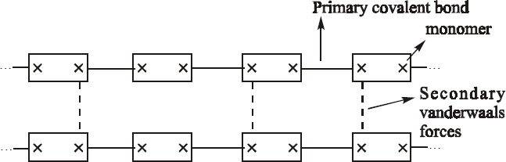

2. When the functionality of monomer is three (tri- functional), three- dimensional network polymer is formed.
Examples for polymers : Urea formaldehyde, phenol formaldehyde.

3. when a trifunctional monomer is mixed in small amounts with a bifunctional monomer, a branched chain polymer is formed.

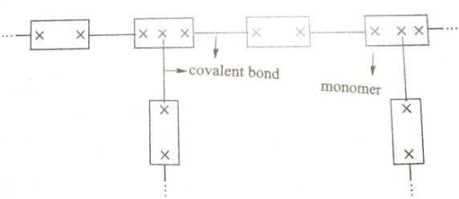

Nomenclature of Polymers

1. Homo Polymers:
Polymers made up of same type of monomers are called homo polymers eg: Polyethylene, PVC
2. Hetero polymers:
Polymers made up of different type of monomers are called hetero polymers eg: buna-s rubber
3. Homochain Polymers:
If the main chain consists of only one type of atoms, then it is called Homo chain Polymers eg: polyethylene. –C-C-C-C-C-C-C-C-
4. Heterochain polymers:
If the main chain consists of different type of atoms, then it is called Hetero chain Polymers
eg: Polyester, Nylon-6. –C-O-C-O-C-O-C-O-

5. Copolymers
Copolymers are two or more different monomers incorporated during the growth of the polymer chain.
alternating copolymer – A – B – A – B – A – B – A – B -
block copolymer – A – A – A – A – B – B – B – B – B – A – A -
random copolymer – B – A – A – B – B – A – A – B – A –
graft copolymer - branches of a different polymer are attached to a polymer chain

Classification of Polymers
There are several ways of classification of polymers.

Classification Based on Source:
Natural Polymers: These polymers are found in plants and animals. Examples are proteins, cellulose, starch, resins and rubber.

Synthetic Polymers: A variety of synthetic polymers as plastic (polythene), synthetic fibres (nylon 6,6) and synthetic rubbers (Buna - S) are examples of man- made polymers.

Classification Based on Backbone of the polymer chain:
Organic and Inorganic Polymers:
A polymer whose backbone chain is essentially made of carbon atoms is termed as organic polymer. The majority of synthetic polymers are organic. Polymers in which chain backbone contains no carbon atom is called inorganic polymers. Glass and silicone rubber are examples of it.

Classification Based on Structure of Polymers:
Linear Polymers: These polymers consist of long and straight chains. The examples are high density polythene, PVC, etc.
Branched Polymers: These polymers contain linear chains having some branches, e.g., low density polythene.
Cross-linked Polymers: These are usually formed from bi- functional and tri- functional monomers and contain strong covalent bonds between various linear polymer chains, e.g. vulcanized rubber, urea- formaldehyde resins, etc. Cross linked polymers are hard and do not melt, soften or dissolve in most cases.
Classification Based on Composition of Polymers:
Homopolymer: A polymer resulting from the polymerization of a single monomer.
Copolymer: When two different types of monomers are joined in the same polymer chain, the polymer is called a copolymer.

Classification Based on Mode of Polymerisation:
Addition Polymers: The addition polymers are formed by the repeated addition of monomer molecules possessing double or triple bonds.
Ex. the formation of polythene from ethene and polypropene from propene.
Condensation Polymers: The condensation polymers are formed by repeated condensation reaction between two different bi- functional or tri- functional monomeric units.
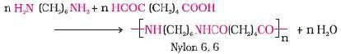
Ex: terylene (dacron), nylon 6, 6, nylon 6, etc. Nylon 6, 6 is formed by the condensation of hexamethylene diamine with adipic acid.
Copolymers: A heteropolymer or copolymer is a polymer derived from two (or more) monomeric species, as opposed to a homopolymer where only one monomer is used.
Ex: SBR, Nitrile rubber, styrene-acrylonitrile
Classification Based on Molecular Forces:
The mechanical properties of polymers are governed by intermolecular forces, e.g., van derWaals forces and hydrogen bonds, present in the polymer. These forces also bind the polymer chains. Under this category, the polymers are classified into the following groups on the basis of magnitude of intermolecular forces present in them.
They are (i) Elastomers (ii) Fibers (iii) Liquid resins (iv) Plastics [(a) Thermoplastic and (b) thermosetting plastic].

They are two types (a) thermoplastic and (b) thermosetting plastic.

Thermoplastic Polymers: Some polymers soften on heating and can be converted into any shape that they can retain on cooling. The process of heating, reshaping and retaining the same on cooling can be repeated several times. Such polymers, that soften on heating and stiffen on cooling, are termed ‘thermoplastics’.
Ex: Polyethylene, PVC, nylon and sealing wax

Thermosetting Polymers: Some polymers, on the other hand, undergo some chemical change on heating and convert themselves into an infusible mass. They are like the yolk of egg, which on heating sets into a mass, and once set, cannot be reshaped. Such polymers, that become infusible and insoluble mass on heating, are called ‘thermosetting” polymers. Ex: bakelite, urea- formaldelyde resins, etc.

Thermoplastics | Thermosetting plastics
Formed either by addition or by Condensation polymerization reactions | Formed by Condensation polymerization reactions
They have either linear or branched structures. | They have three dimensionalcross linked net work structures
Adjacent polymer chains are held together by either vanderwaals forces, or by dipole- dipole forces or by hydrogen bonds | Adjascent polymer chains are held together by strong covalent bonds called crossed-links
They soften on heating and stiffen on cooling | They do not soften on heating.
Low molecular weight thermoplastics are  soluble in their suitable solvents. | They are insoluble in any solvent.
hey can be remoulded, re-shaped and re- used. | They can be reclaimed from waste i.e., they can be recycled
here is no change in chemical  omposition and structure during moulding rocess. | They undergo chemical changes such as  further polymerisation and cross-linking during moulding process.
They are soft and flexible | They are hard, rigid and infusible.
They can be reclaimed from waste i.e., they can be recycled. | They cannot be reclaimed from waste. They cannot be recycled.
They undergo reversible changes, on the application of heat. | They undergo irreversible changes on the application of heat.
They swell or dissolve in organic solvents. | They neither dissolve nor swell in organic solvents.
They are tough materials | They are brittle materials
The moulded articles are to be cooled to room temperature before taking out from the  moulds to avoid deformation. | The moulded articles can be taken out of the moulds even when they are still hot without  any deformations
Curing can be done by cooling. | Curing can be done by applying heat and  pressure.
Examples:  Polyethylene(PE), bakelite. | Examples: Phenol- formalde-hyde resin (PF), urea- formaldehyde resin

Types of Polymerization
There are four types of polymerisation reactions
(a) Addition or chain growth polymerisation
(b) Condensation or step growth polymerisation and

(c) Copolymerization

Addition Polymerisation: In this type of polymerisation, the molecules of the same monomer or different monomers add together on a large scale to form a polymer. The monomers normally employed in this type of polymerization contain a carbon-carbon double bond (unsaturated compounds, e.g., alkenes and their derivatives) that can participate in a chain reaction.

Condenstion Polymerisation: In this type of polymerisation, the two different types of monomer condense together to form polymer. Elimination of small molecules takes place. By products are formed. Ex. Formation of Nylon 6,6

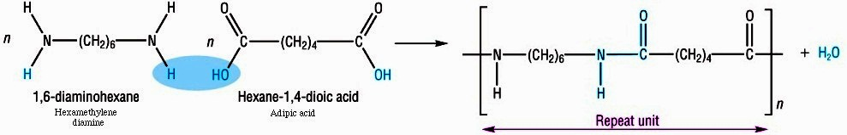

Co – Polymerisation: In this type of polymerisation, the two different types of monomer
combines together to form polymer. No elimination takes place. Mainly produce high molecular weight compound

Mechanism of Addition Polymerisation
Addition polymerization occurs by three mechanisms. They are
1. Free radical Polymerisation
2. Ionic Polymerisation
3. Coordination Polymerisation

FREE – RADICAL MECHANISM OF POLYMERIZATION.
The free radical mechanism occurs in three major steps:
- 1.Initiation
- 2.Propagation
- 3.Termination
I. Initiation :
This involves two reactions :
First reaction involves production of free radical
Free radical is formed by hemolytic dissociation of an initiator ( or) catalyst
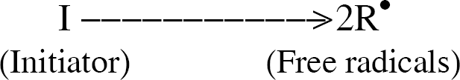
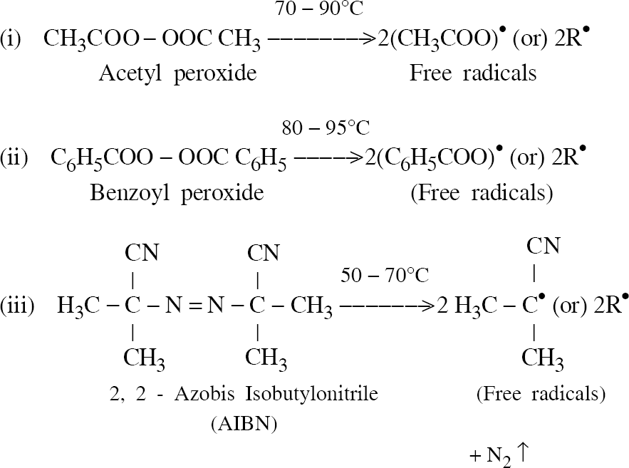
Second reaction : Addition of the free radical with the first monomer to give chain initiating species :
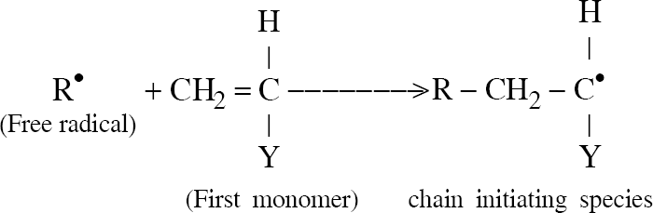
II :Propagation :
Here growth of chain initiating species occurs by successive addition of large number of monomers. The growing chain of the polymer is known as living polymer.
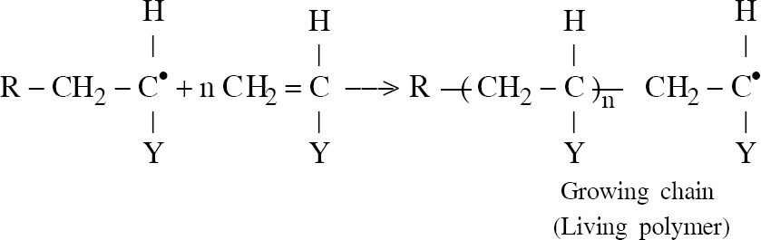
III :Termination :
Termination of a growing chain of polymer may occur by
(i) Coupling (or ) combination
(ii) Disproportionation
Coupling or combination
Here coupling of free radical of one chain end to another free radical occurs to
form a macro molecule.
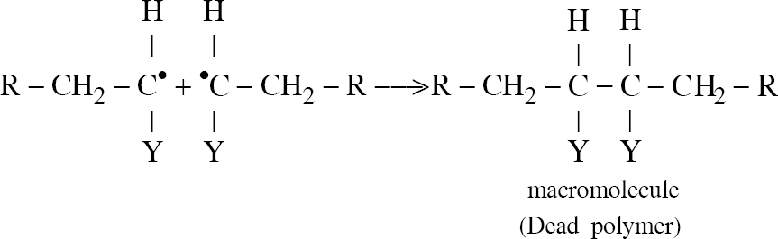
Disproportionation :
Here transfer of hydrogen from one radical to another radical occurs to form
two macromolecules, one is saturated and the other is unsaturated.
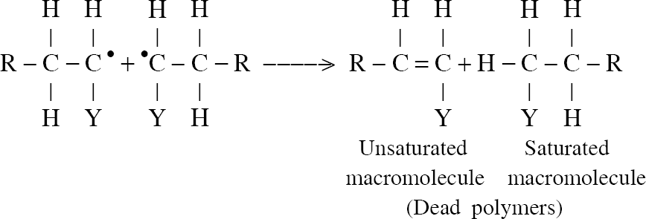
The products of addition polymerisation is known as Dead Polymers

Ionic mechanism of polymerization:

A. Cationic Mechanism
- It is faster than free radical mechanism
- In this mechanism monomer contains electron donating groups
- Example: Styrene, Isobutylene, Isoprene
- It involves three step
    - Intiation
    - Propagation
    - Termination
1. Initiation: It involves two steps.
Step 1: Formation of positive ions
    - It is formed from the initiator (or) catalyst
    - Here the acids like AlCl₃, BF₃, CCl₄ are act as a Initiator
    - These acids do not have proton and react with Co catalyst
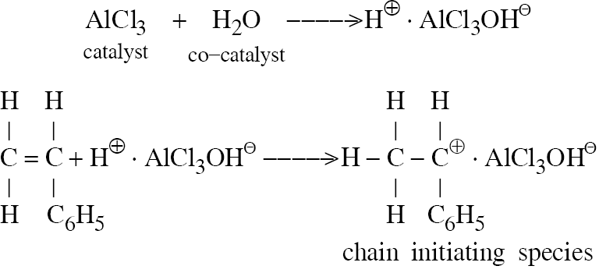
Step 2: Combination of positive ions with the monomer to form carbocations

2. Propagation
In this step the initiating species combines with new monomer to form living polymer

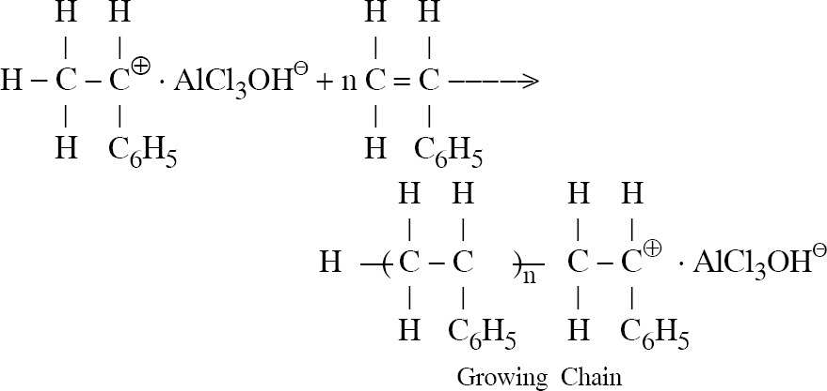
3. Termination
In this step the proton (H⁺) removed from the initiating species to form dead polymer and carbonium ion can be separated .
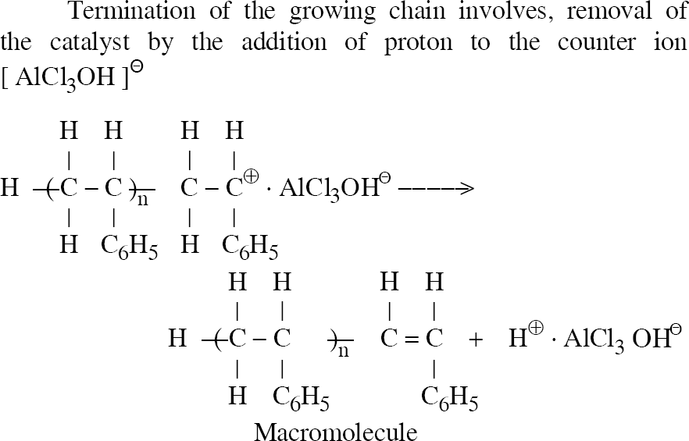

B. Anionic Mechanism:
- In this mechanism the monomer contains electron withdrawing groups like Cl⁻ & CN⁻.
- Example: Vinyl chloride, Styrene, Acrylonitrile
- It involves three step
    - Intiation
    - Propagation
    - Termination
I. Initiation
It involves two steps
Step I: Formation of Negative ions
    - It is formed from the initiatar (or) catalyst
    - Here the Lewis base like KNH₂ & NaNH₂ are act as a Initiator

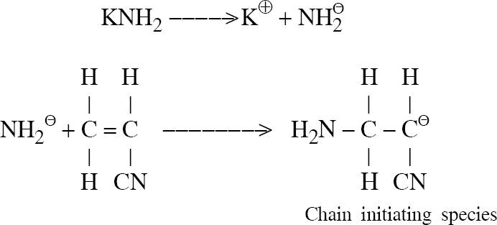
Step 2: Combination of negative ions with the monomer to form carbanions

II. Propagation
In this step the initiating species combines with new monomer to form living polymer

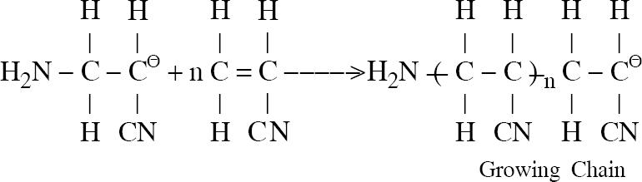
III. Termination
In this step the living polymer combines with base (NH₃) to form dead polymer

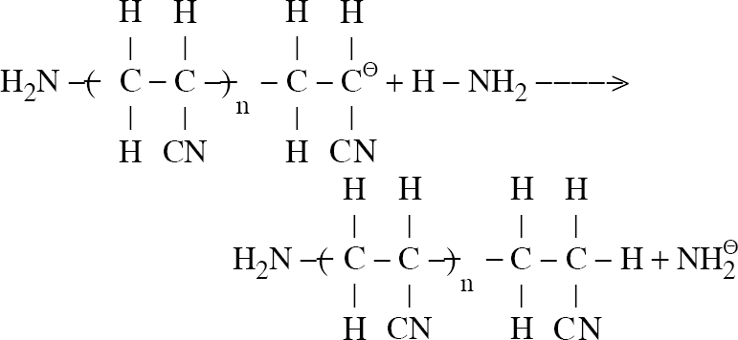

Properties of Polymers

Tacticity (or) Stereospecific polymer
Definition
The functional group arranged in the polymer takes place in an orderly or disorderly arrangement to the main chain is known as Tacticity.
The polymers are classified into three types based on tacticity.
a. Isotactic Polymer
The arrangement of functional group in the same side of the polymer is known as Isoatactic
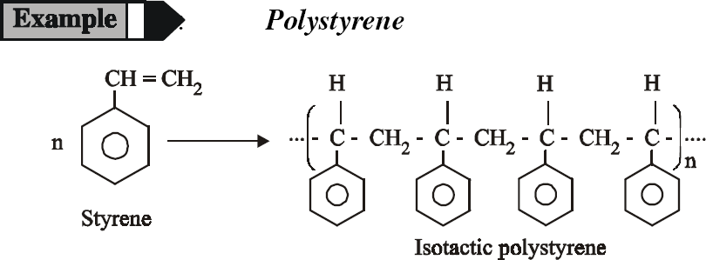

b. Syndiotactic Polymer
The arrangement of functional group in the opposite side of the polymer is known as Syndiotactic
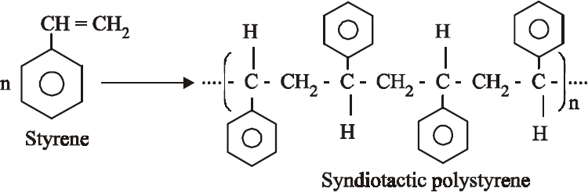

c. Atactic Polymer
The arrangement of functional group in the random side of the polymer is known as Atactic
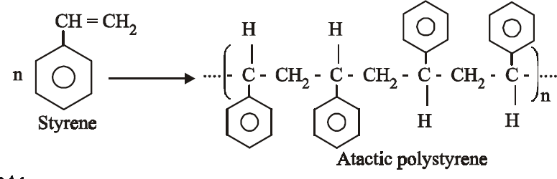

Tg (Glass transition temperature)

Definition
It is defined as the temperature at which the amorphous solid transformed into liquid is known as glass transition temperature
Examples : Tg of Polystyrene = 100 ºC
Polycarbonate = 150 ºC

Based on their Tg, Polymer is classified in to two state

Rubbery state (Soft) (Above Tg)
Glassious state (Hard) (Below Tg)

Factors influencing Tg
  - Increase in chain length – Tg increases
  - High strength – Tg increases
  - Rate of heating (or) cooling
Significance (or) Uses
  - It is one of the important property of polymer
  - It is used to decide whether the polymer is soft (or) hard
  - It is used to identify the processing temperature of polymer

Molecular mass
Definition
Molecular weight depends on the number of monomer present in the polymer
Based on their molecular mass, it is classified into 2 types
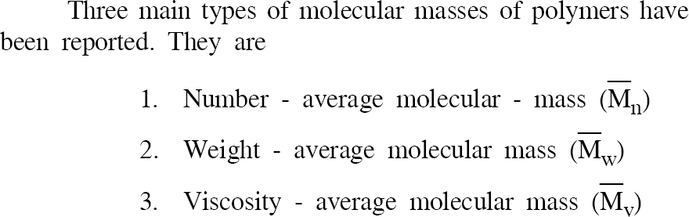
1. Number average Molecular mass
2. Weight Average Molecular mas

Number Average Molecular Mass
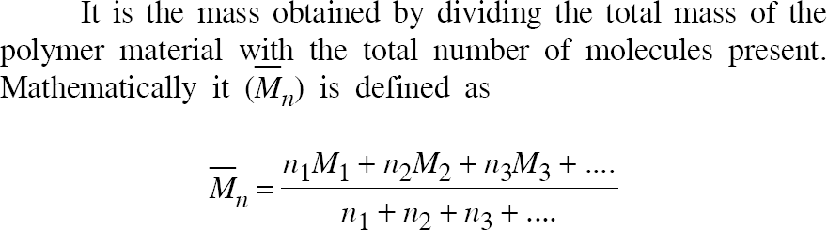
Is mass obtained by dividing total molecular mass of polymer with number of monomer present in it

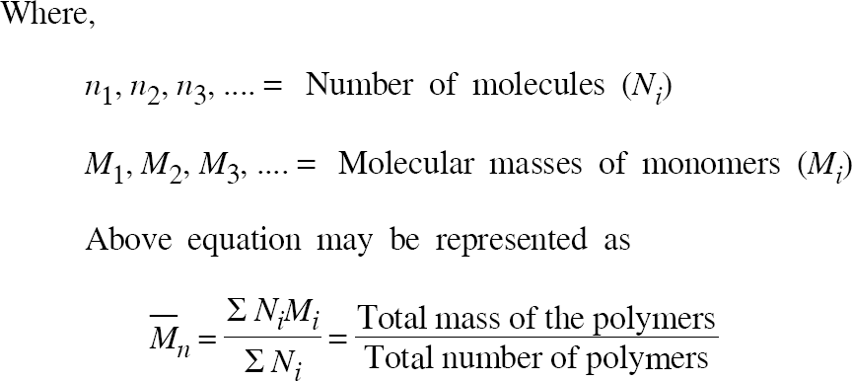

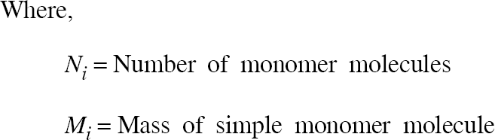

Weight Average Molecular Mass

- It is not only depends on number of monomer but also depends on mass of the monomer
- Hence it is averaging process the molecular weight of each individual species is divided by mass not by number.

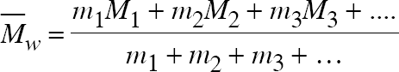

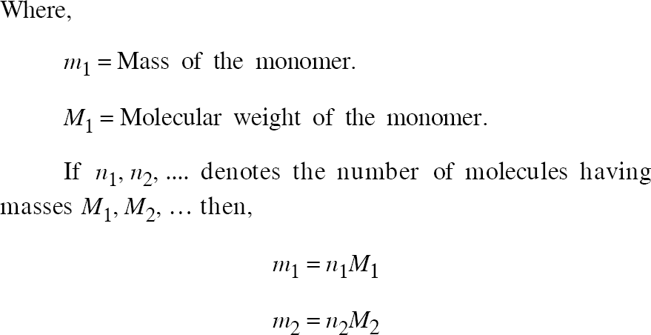

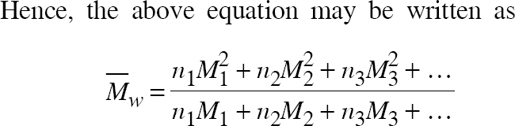

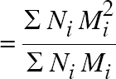

Determination
Weight – average molecular mass is determined by light scattering techniques and ultra centrifugation techniques.

TECHNIQUES OF POLYMERIZATON

BULK POLYMERISATION
Aim:
To prepare PVC, PVA, PS by bulk polymerisation method
Apparatus required:
Thermoflask, Thermostat, condenser and required reagent
Procedure:
  - It is also called as mass polymerisation
  - In this polymerisation, the monomer is taken in the flask as a liquid form and initiator, chain transfer agent dissolve in it
  - The flask is placed in a thermostat under constant agitation and heat
  - The reaction is slow but becomes fast as the temperature increases.
  - After a known period of time, the polymers are formed and separated out

Reaction

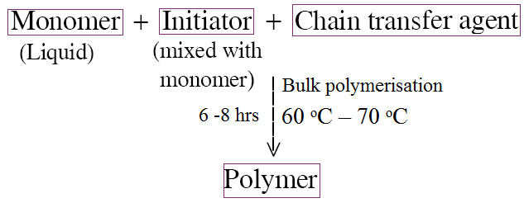
Advantages:
  - Using simple equipment.
  - Highly pure polymers are formed.
Disadvantages:
  - The reaction is highly exothermic and sometime it is not possible to control the explosion.
  - It is not possible to produce large amount of polymer
Application:
  - Mainly produces low molecular weight polymer used as adhesive and additives in lubricants.

SOLUTION POLYMERISATION
Aim:
To prepare polyisobutylene, PAN by solution method
Apparatus required:
Thermoflask, Thermostat, condenser and required reagent
Procedure:
  - In this method the monomer, initiator and chain transfer agent taken into the flask and dissolved in inert solvent (Eg: Alcohol)
  - The above mixture is kept under constant agitation
  - After some time, the above content is transfer into the suitable solvent.
  - The polymers are separated out
Advantages:
  - Heat control is easy
  - The mixture can be agitated easily
Disadvantages:
  - The removal of solvent is difficult.
  - It is difficult to get high molecular weight polymer.
Application:
  - It is also used as adhesives.

SUSPENSION POLYMERISATION (or) Beads Polymerisation (or) Pearls Polymerisation
Aim:
To prepare PS and polystyrenedivinylbenzene by suspension polymerisation method
Apparatus required:
500 mL beaker, stirrer, heating bath and required reagent.
Procedure:
  - This method is used only for water insoluble monomer.
  - This polymerisation reaction is carried out in heterogeneous system.
  - At the end of the step, the polymer is separated out as beads or pearls so it is called s beads or pearls polymerisation.
  - The water insoluble monomer is suspended in water, and the initiator is dissolve by agitation.
  - By adding suspending agent Al₂(SO₄)₃ and methyl cellulose, PVA (polyvinylacetate).
  - The whole content taken in a flask and heated.
  - At the end the beads polymers are formed.
Reaction

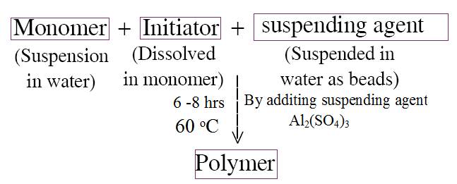
Advantage:
  - Products obtained is highly pure.
  - Efficient heat control.
  - More economical (because water is used as solvent)
Disadvantage:
  - Applicable only for water insoluble monomer.
  - Control of particle size is difficult
Application:
  - It is mainly used for water purification (Ion exchange method).

EMULSION POLYMERISATION
Aim:
To prepare PVC and PVA.
Apparatus required:
500 mL beaker, thermometer, stirrer, heating bath and required reagent.
Procedure:
  - It is carried out by using heterogeneous system.
  - In this method, the water insoluble monomer and water soluble initiator potassium persulphate (KHSO₄) is taken into the flask.
  - In this above content, mixed with emulsified like soap is added.
  - The above content is heated with thermostat at 4 – 5 hours.
  - Now all the mixtures are completely dissolved.
  - After completion the reaction by adding demulsifying agent (Al₂(SO₄)₃, The polymer is separated out.

Reaction:
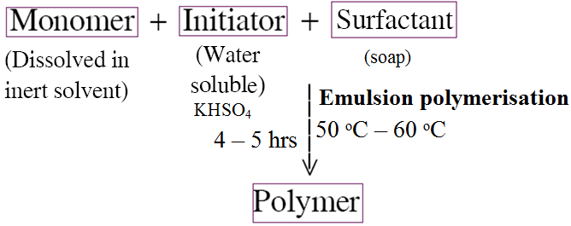
Advantage:
  - High molecular weight polymers are produced
  - The rate of polymerisation is high
Disadvantage:
  - The polymers need purification
  - It requires rapid agitation
Application:
  - It is used in paint industry and plastic industry.

PREPARATION, PROPERTIES AND USES OF THE POLYMERS:
Polyethylene:
This can be obtained by the polymerization of ethylene at 1500 atm and at a temperature of 150 – 250 ⁰C in presence of traces of oxygen.

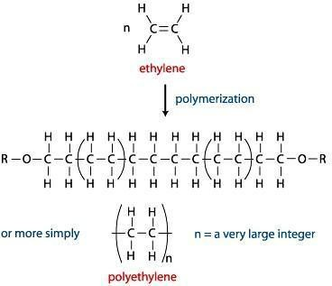

Properties:
- Depending upon the density, they may be LDPE and HDPE. If we use free radical initiator, LDPE is the product while use of ionic catalysts results in the formation of HDPE. LDPE has a density 0.91 to 0.925 g/cm³. HDPE has a density 0.941 to 0.965 g/cm³. HDPE is linear and has better chemical resistance.
- It is a rigid, waxy white solid. Translucent.
- It is permeable to many organic solvents.
- It crystallizes easily.
Uses:
- These are useful in the preparation of insulator parts, bottle caps, flexible bottles, pipes etc.
- LDPE is used in making film and sheeting. Pipes made of LDPE are used for both
agricultural, irrigation and domestic water line connections.
- HDPE is used in manufacture of toys and other household articles.

PVC :
Poly Vinyl Chloride is obtained by heating a water emulsion of vinyl chloride in presence of a small amount of benzoyl peroxide or hydrogen peroxide in an auto clave under pressure. Vinyl chloride, so needed is generally prepared by treating acetylene at 1 to 1.5 atmospheres with hydrogen chloride at 60⁰C to 80⁰C in the presence of metal chloride as catalyst.
CH = CH + HCl →CH₂ = CH Cl

Properties:
- It occurs as a colourless rigid mater
- It is having high density and low softening point.
- It is resistant to light, atmospheric oxygen, inorganic acids and alkalis. 4.It is most widely used synthetic plastic.

Uses:
- It is mainly used as cable insulation, leather cloth, packing and toy
- It is used for manufacturing of film, sheet and floor covering.
- PVC pipes are used for carrying corrosive chemicals in petrochemical factories.

Nylon:
Synthetic fiber forming polyamides are termed as ‘Nylons’. Among the different nylons, Nylon 6:6 and Nylon -6 are important for fiber. The number indicates number of carbon atoms in the material from which is made.
General Properties
1. Nylons are translucent, whitest, horny and high melting polymers.
2. They possess high temperature stability and good abrasion resistance.
3. They are insoluble in common organic solvents and soluble in phenol and formic acid.
Nylon – 6:6
Preparation
Nylon 6:6 is obtained by the polymerization of adipic acid and hexamethylenediamine.
Properties
  - They are not soluble in organic solvents but soluble in phenol and formic acid.
- It’s melting point is 264ºC
  - It is less stiff soft material compared to Nylon 6.

Nylon- 6
It is prepared by self-Polymerisation of caprolactam.
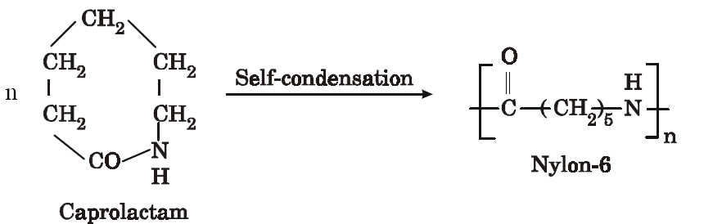

Properties
  - It is tough and highly heat resistant
  - It is in soluble in organic solvent
  - It is light weight, soft, less stiff
  - Its melting point is 225ºC

Nylon – 11
It is prepared by self condensation of ω-undecanoic acid.
Uses:
- Nylon -6:6 is primarily used for fibers that find use in making socks, undergarments, carpets etc.,
- Nylon -6:6 is also used in mechanical engineering for well known applications like gears, bearings, bushes, cans etc.,
- Nylon -6:6 is also used for facketing electrical ware to provide a tough, abrasion resistant outer cover to protect the primary electrical insulation.
- Nylon 6 is mainly used for making tyre cords.
- Nylon 6:10 is suitable for monofilaments that are used for bristles, brushes etc.,
- Glass reinforced Nylon plastics are used in housings and cosings of domestic appliances, radiator parts of car and for relay coil formers.
Bakelite:
Preparation :
It is prepared by condensing phenol with formaldehyde in presence of acidic/alkaline catalyst. The initial reaction results in the formation of O- and P- hydroxyl methyl/phenol which reacts to form linear polymer. During modeling hexamethylene tetramine is added, which converts to insoluble solid of cross-linked structure. Commercially these are available in two forms nova lacks & resols.

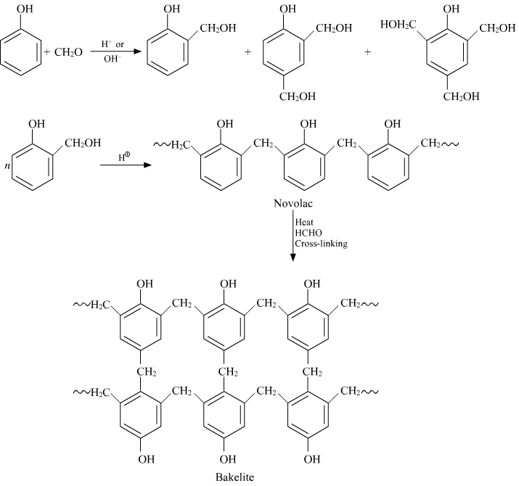

Properties.
- Phenolic resins are hard, rigid and strong materials They have excellent heat and moisture resistance.
- They have good chemical resitance.
- They have good abrasion resistance.
- They have electrical insulation characteristics
- They are usually dark coloured.
- Lower molecular weight grades have excellent bonding strength and adhesive properties.

Uses:
Phenol formaldehyde resins are used for
- Domestic plugs and switches
- Handles for cooker and saucepans.
- Distributor heads for cars
- Adhesives for grinding wheels and brake linings.Varnishes, electrical insulation and protective coatings.
- The production of ion exchange resins.

Epoxy Resins
Preparation
  - It is prepared by heating a mixture of Bis-phenol and epichlorohydrin under alkaline catalyst (NaOH) at 60 ºC
  - It is one of the important cross linked synthetic polymer.
  - It contains ether linkage R – O – R

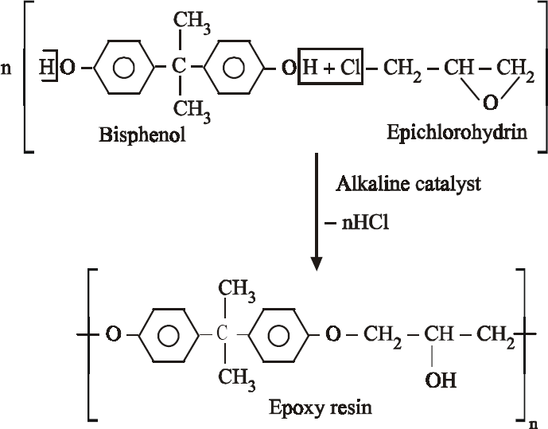
Properties
- Due to the ether linkage it is highly resistance to acids and alkalies.
- It is highly heat resistance
- Because of the polar group / polar nature it is highly adhesive in property
- It is not soluble in organic solvents.
Uses
- It is used for making surface coating material like araldite.
- It is used for protective shield in air craft components.
- It is used for blending agent ( to avoid shrinkage and crease resistance) in wool.

